DataBase Schema:
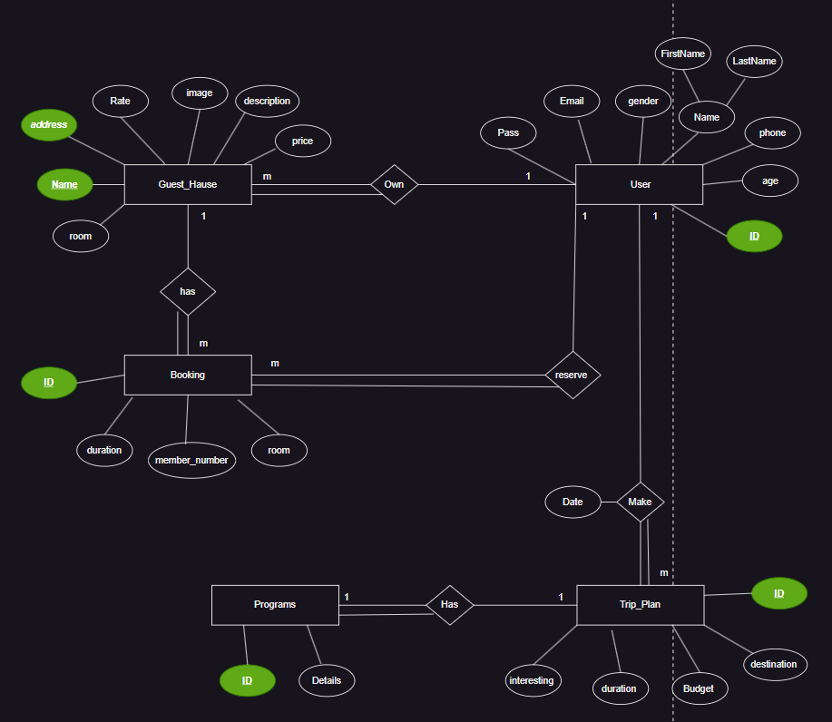

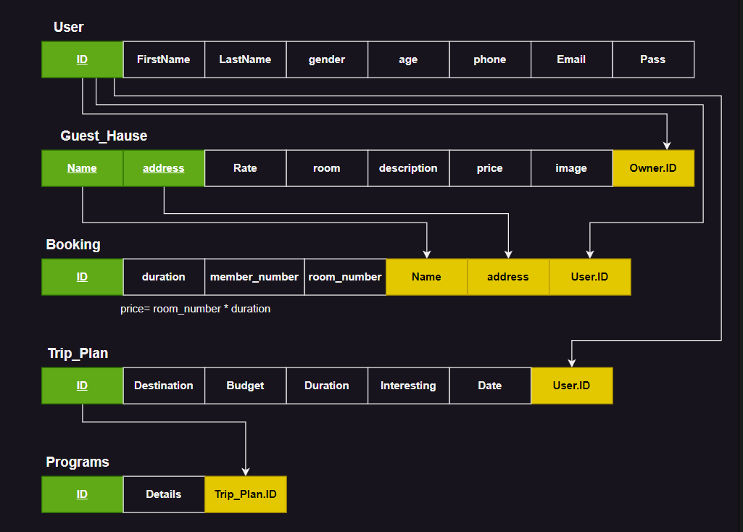

Mustafa Mohamed Roshdy:
Created the Booking entity and its table

Youssef Mohamed:
Created the Guest_Hause entity and its table

Menna Hosny:
Created the User entity and its table

Rawan Essam:
Created Trip_Plan and Programs entities and their tables

